Foundation Core (BA640 Fin Reporting, BA642 Stats, BA643 Econ and BA644 Ops Mgmt)

The Foundational Core (10 total units) is a set of six courses designed to provide students with the basic knowledge, terminology and business acumen. They are the prerequisites for more advanced classes such as the professional core classes, electives, and culminating experience class. These core courses are mainly for the MBA program but may apply to MS in Information System and Accountancy programs.

The courses are as follows:
BA 640 Financial Planning and Analysis, 2 units
BA 641 Business Ethics and Corporate Responsibility, 1 unit
BA 642 Statistical Analysis, 2 units
BA 643 Managerial Economics, 2 units
BA 644 Operations and Supply Chain, 2 units
BA 645 Marketing, 1 unit

The two unit courses are paired to give students the opportunity to come to campus less often while taking more classes. If students are taking paired classes correctly, they only need to come to the campus once a week and will be able to complete 4 units. The course pairs are:
BA 640 and BA 643
BA 642 and BA 644

The courses are offered every other week and partially online, see diagram below:
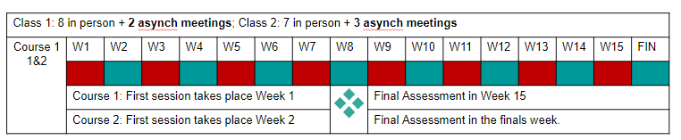
For example, a student may register for both classes: BA 640 and BA 643. During weeks one, three, five etc, they will attend BA 640. During weeks two, four, and six etc, the student will attend BA 643. If a student only needs to take one class of the two, they will come to campus for classes every other week. The paired class details will be announced on the my.SDSU Course Detail section.

